1977 Wrestling Team
Athletic Team Inductee
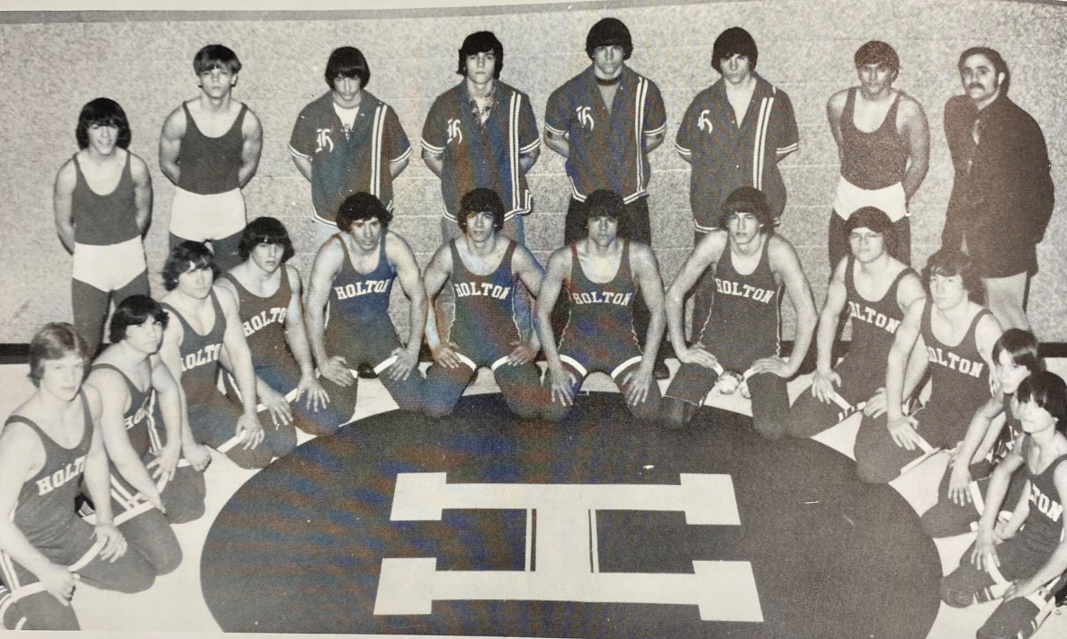
Back Row: (l to r): JV Wrestlers and Coach Jack Deming. Front Row: (l to r): Craig Cramblet, Ed Hanes, Gene Harris, Rich Allen, Kelvin Harris, Joe Hunt, Randy Haugen, Bob Furman, Curt Marshall, Doug Kuck, Kent Bates, Ted Fox. Not Pictured: Dennis Alvesteffer.

1977 Varsity Wrestling Team
Holton 47 North Muskegon 19
Holton 60 Muskegon Heights 10
Holton 37 Montague 22
Holton 50 Allendale 12
Holton 42 North Muskegon 13
Holton 37 Hesperia 26
Holton 54 Homer 18
Holton 34 Eaton Rapids J.V. 24
Holton 22 Michigan Lutheran Seminary 36
Holton 42 Tri-County 12
Holton 21 Ravenna 44
Holton 50 Tri-County 15
Holton 50 Oakridge 15

Conference Champions
Regional Runner-Up
State Tournament 3rd Place
Overall Record 11 – 2

